Physics Question
9) Intensity of sound wave is given by:
I=5.24x10⁻⁵ W/M²
Intensity Level is B=10log₁₀ (I/I₀)
=10log₁₀ (5.24x10⁻⁵/10⁻¹²) dB
=77.2 dB

10) Weight overhanging from the pulley = weight of hanging mass + weight of hanging string
weight overhanging from the pulley = 265g + (30/120)*80 = 265 + 20 = 285 g
Tension in the string = mg = 0.285*10N = 2.85N
The density of string = 80g/120cm = 0.08/1.2 = 0.066kg/m
A) V of wave = sqrt (T/density) = sqrt (2.85/0.066) = 6.57m/s
B) Lamba = 2/4L = 2/4*90 = 45cm
Frequency = v/lamba = 6.57/0.45 = 14.6H

11) Frequency F= 1/2π√K/m
Where K= spring constant
M=mass
Therefore F1/F2=√M1/M2
=3.95Hz/F2=√380g/200g
F2=2.87Hz
12) Formulae=0.5xdensity x speed
Density=1.2Kg/M³
Speed=15 M/s
=0.5 x 1.2 x 15²
=0.5 x 1.2 x 225
=135N/M²
Therefore the pressure is higher inside.

13) a) time of flight of the object
T=2usinƟ/g
T=2*22*sin55/9.81
T=44*sin55/9.81
T=36.0427/9.81
T=3.674seconds
b) The distance it travelled horizontally
Range=u²sinƟ/g
R=22² x sin (2*55)/9.81
R=44x0.93969/9.81
R=46.36m

14) a) m x 48 + 3m x 0=M x 0 +3m xV₂
=48m=3mV₂
=V=16m/s
b)$K/K=4m1m2/(m1+m2)2$
=12/16
=75%

15)
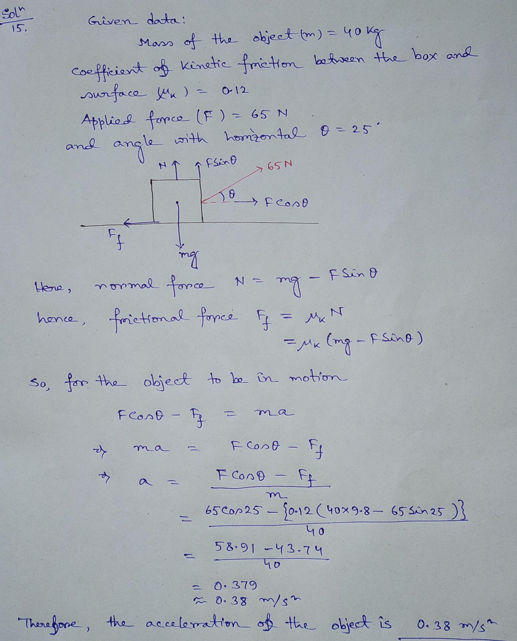
16) Radius=8.5cm
Ns=0.34
For minimum rate of rotation
Fs=MW²R
N x G= W²r
Therefore=w=0.34 x 9.8 x 100/8.5
W=√39.2=W=6.26rad/sec
=6.26/2π x 60 sec/min
Maximum rate =W=59.77 rev /min
17) If the bullet embeds in block then it will transfer all its kinetic energy in the block which will increase its temperature.
K.E of bullet =1/2mv²
=1/2 x 5 x (10²) =600 x 386 x Dt
DT=5 x 10 ⁴/2 x 600 x 386=107k

18) Speed on sand=1.2m/s
Time taken to cross=48/1.2=40s
Let his speed in V on the pavement
Time taken to cross 102m=t₂=102/v s
Total time =t1+t2= (40+102/v) s
Total distance travelled=48+102=150m
If his average was 2m/s then total time taken to cross 150m=150/2= 75 sec
40+102/v=75
V=102/35
=2.91M/s

